**Report**

**Website Information:**

Name: State Bank of India

Domain: [onlinesbi.sbi](https://onlinesbi.sbi/)

Employees: 10K – 50K

Type: Private

Annual Revenue: 1,300,000,000

City: Mumbai

State: Maharashtra

Country: India

**Social Media Information:**

Twitter: <https://twitter.com/TheOfficialSBI>

Facebook: <https://facebook.com/statebankofindia>

LinkedIn: <https://linkedin.com/company/state-bank-of-india>

**Information Gathered by Shodan:**

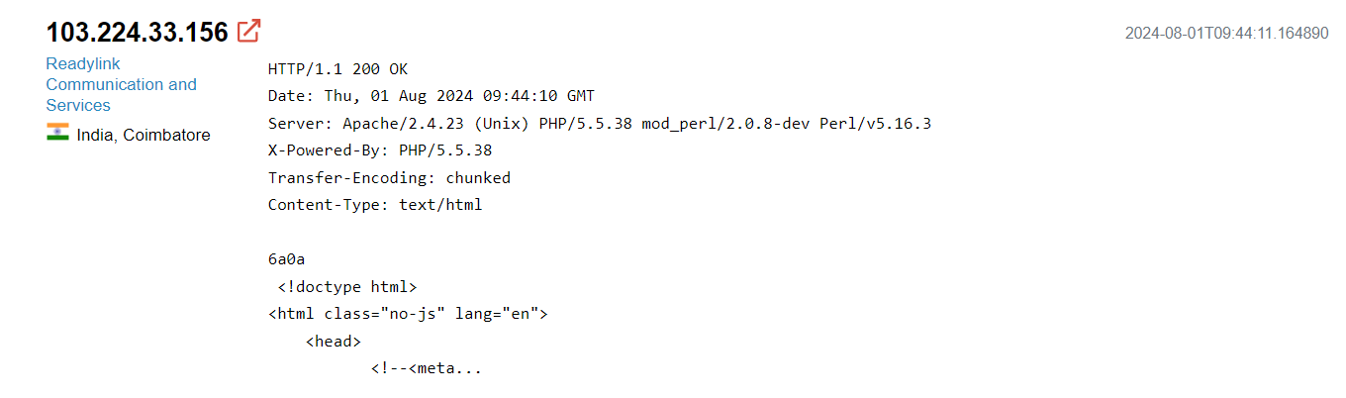

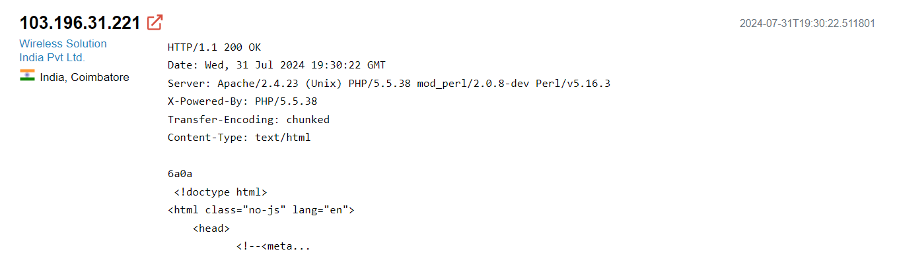

**Sub domains:**

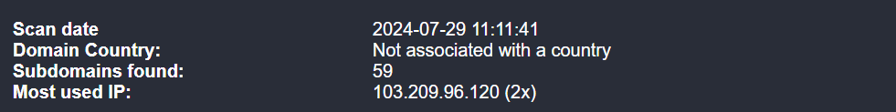

corp.onlinesbi.sbi

dvmerchant.onlinesbi.sbi

eforex.onlinesbi.sbi

esbtr.onlinesbi.sbi

fs.onlinesbi.sbi

inblotus.onlinesbi.sbi

inbsfg.onlinesbi.sbi

merchant.onlinesbi.sbi

mobilewm.onlinesbi.sbi

oaa.onlinesbi.sbi

portalwm.onlinesbi.sbi

retail.onlinesbi.sbi

uatcorp.onlinesbi.sbi

uatmerchant.onlinesbi.sbi

uatretail.onlinesbi.sbi

Geographic Location:

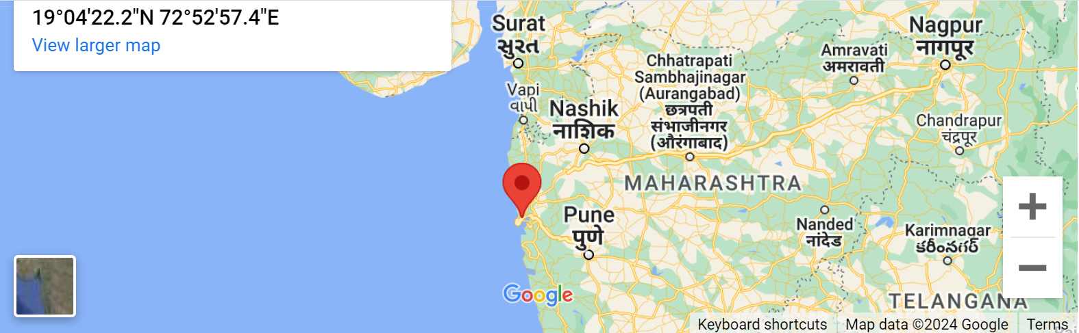

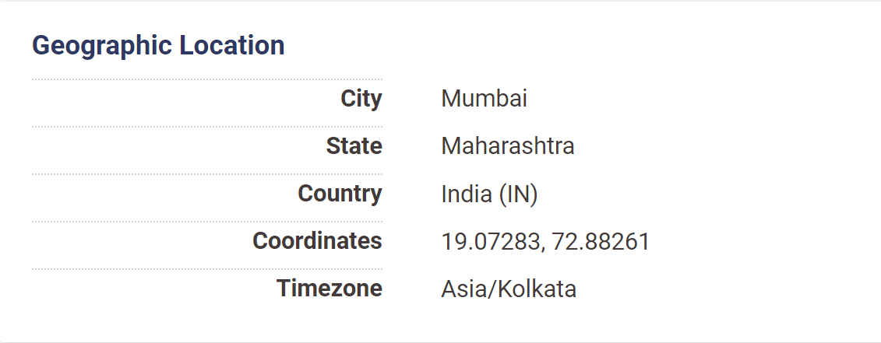

**Firewall:**

The site <https://sbi.co.in> is behind BIG-IP Appsec Manager (F5 Networks) WAF.

**Host Addresses:**

sbi.co.in. 103.209.96.176

**Name Servers:**

pdns.satyam.net.in. 202.144.63.4

sdns.satyam.net.in. 202.144.63.12

**Mail (MX) Server:**

sbi-co-in.mail.protection.outlook.com. 52.101.145.0

sbi-co-in.mail.protection.outlook.com. 52.101.144.3

sbi-co-in.mail.protection.outlook.com. 52.101.144.0

sbi-co-in.mail.protection.outlook.com. 52.101.145.2

**Technologies Used:**

